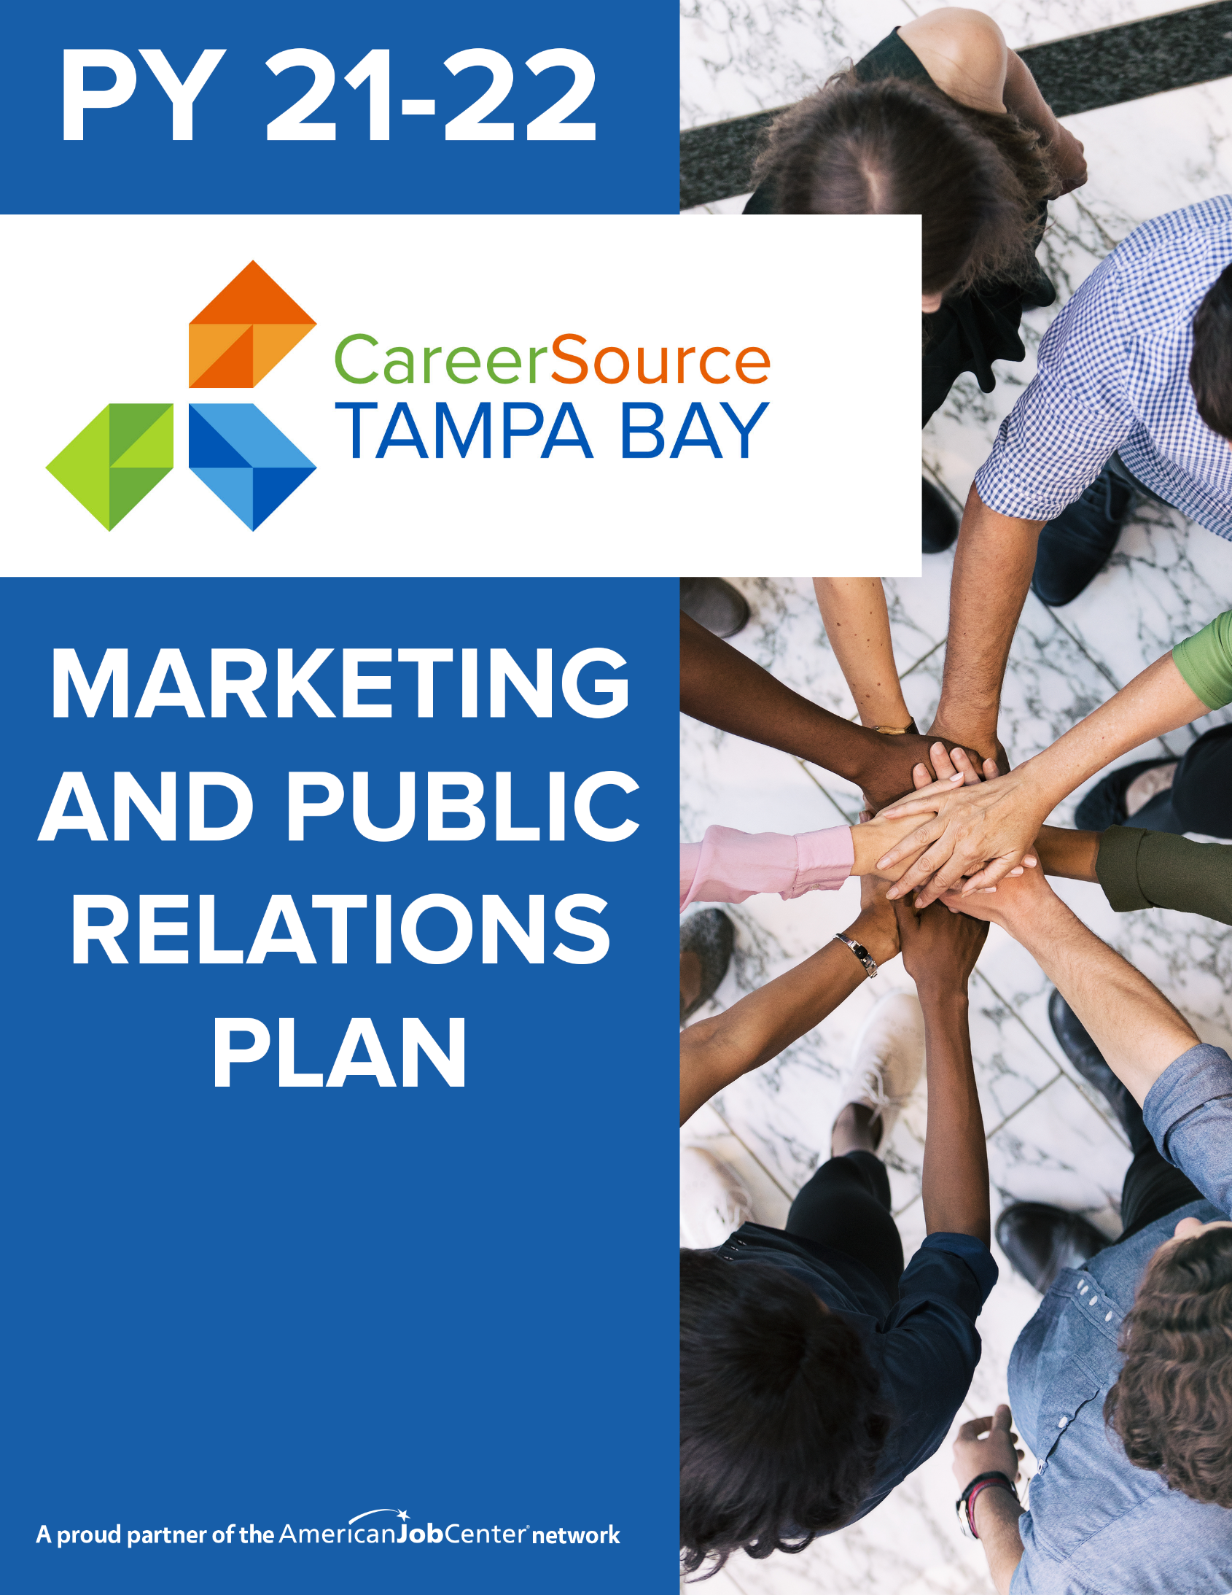

Table of Contents

CSTB Marketing Plan………………………………………………………………..Page 3

CSTB Communication Plan……………………………………………………….Page 6

Marketing, Public Relations, Social Media, News Media Policy..Page 9

CSTB Marketing Team………………………………………………………………Page 9

2021-22 CSTB Marketing Plan

(Updated June 30, 2022)

This document outlines the plan to promote CareerSource Tampa Bay (CSTB) via our paid media effort in order to maximize Brand Awareness.
Marketing Budget: The Marketing/PR budget is updated annually. Fiscal provides the department with a general budget around June of year with a final figure by the end of August. The budget will be updated by VP of Marketing/Public Relations annually. The below figures represents the marketing/outreach/public relations budget for Program year 2021-2022.
When you include monies from grants and programs the overall marketing budget comes to $400,000 for Program Year (PY) 2020-21. This includes the following breakdown:
- General Brand Awareness (Advertising) for CSTB was $285,816 in PY 2021-22.
- Marketing support and training was $41,296 in PY 2020-2021 and $68,933 in PY 21-22.
- CSTB Sponsorships increased from $25,000 in PY 20-21 to $45,500 in PY 21-22. This includes sponsorships for Junior Achievement, EDC, Chamber of Commerce and Tampa Bay Tech,)
- Get There Faster Grant (2-year budget) $40,000 of which $26,623 is available for marketing. In PY 21-22 we used $10,000 for a lead generation campaign.
- Tampa Bay Summer Hires budget for PY 21-22 was $45,680.
- Google Ad Dollars Grant ($10,000)
- The CSTB General Advertising budget is $285,816 for program year 2021-22.
Marketing Funnel: The CSTB Marketing team takes the approach of a marketing funnel to increase brand awareness. We start by bringing wide awareness about CSTB, followed by direct connection with our audiences, which in turn brings people to the website or to our centers, and brings the customer to use our services and programs.
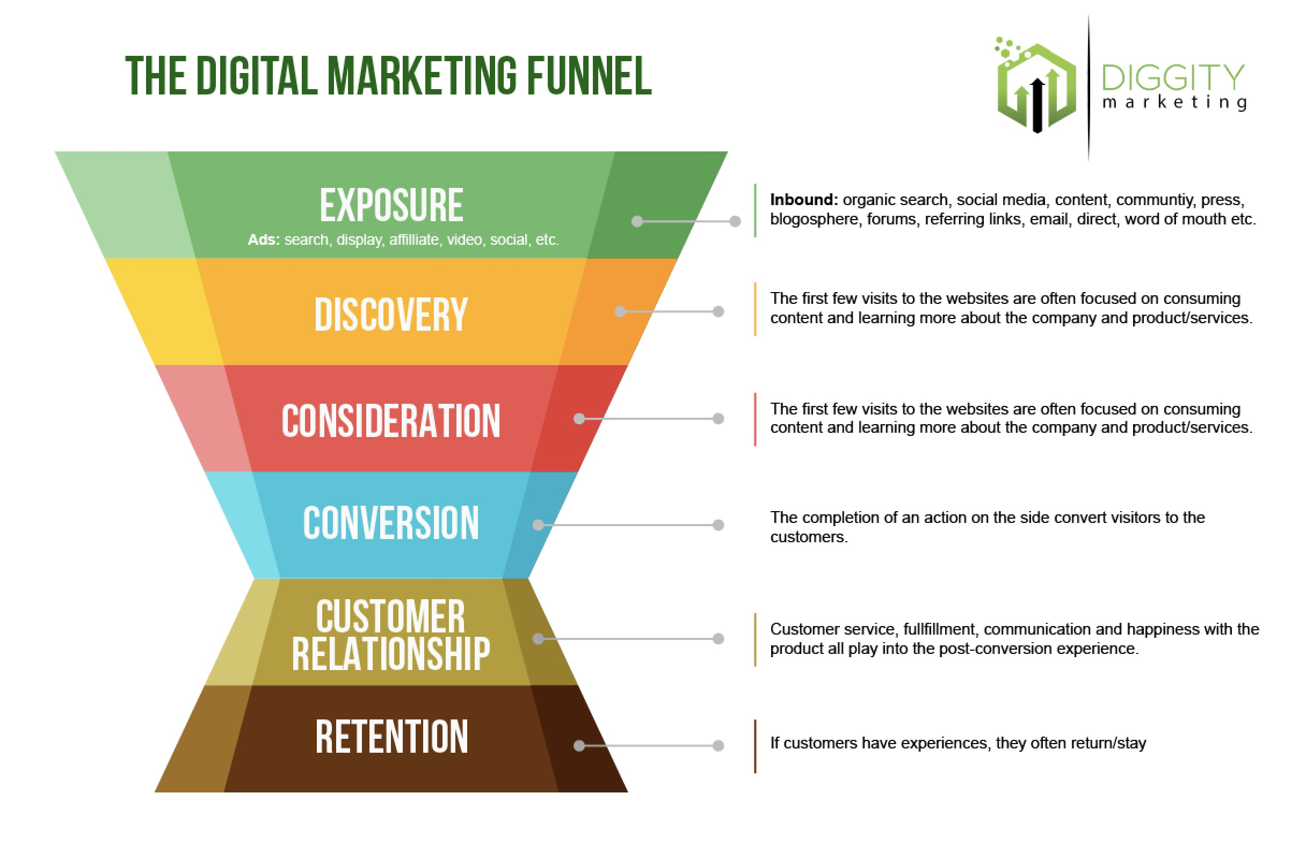
Measurement: CSTB Marketing will make sure we have outreach campaigns that can be measured. We do this in a variety of ways, such as measuring the audience that comes to our websites, how many quality leads are generated and how many people sign up to use those services.
General Branding Awareness Campaign: Each year marketing is allocated with monies that must promote all CSTB services. In program year 2021-22 CSTB Marketing budgeted $285,816 for this purpose. In program year 2022-23 marketing expects the amount of fiscal dollars available for a General Branding Awareness Campaign to decrease 20-30%. This campaign by the KPI’s (see chart below on page 6.) With the reduction of advertising dollars the VP of Marketing/Public Relations will be looking to pinpoint the advertising dollars. The plan for the 2022-23 campaign will be to focus on two areas: 1. Increase website traffic, 2. Increase social media followers. We will also be looking at the feasibility of doing a Road Trip Nation outreach effort which has been nationally acclaimed, but it will depend on funding and DEO approval.
2021-2022 Marketing Report
Program Marketing & Lead Generation Campaigns: The CSTB Marketing team works closely with CSTB programs to generate leads such as: Youth, Veterans, Information Technology and Medical Training. We develop marketing plans to help departments achieve their goals. While marketing can help it should also be supported by programs with human resource support, outreach support and ability to answer questions that can be generated from the marketing effort. In program year 2021-22 marketing did campaigns to support:
- Tampa Bay Summer Hires ($45,680)
- Get There Faster Grant Lead Generation Campiagn ($10,000)
- Tampa Bay Summer Hires ($18,772)
- Vision 2022 ($23,384)
Other areas to promote in 22-23 include:
- Tobacco Free Florida (marketing supported with collaterals, flyers, pop up banners ($1,000)
- Youth Summit
Paid Media: This is media that is generated via paying for the publicity. This can be found in various ways such as billboards, stories in print publications, advertisements in print publications, radio, digital marketing (display ads), social media marketing, Google and other search engines. A complete report of CSTB paid media for PY 2021-22 can be found at the following link: https://careersourcetampabay.com/wp-content/uploads/Agenda-Packet-August-18-2022-Board-of-Directors-Meeting.pdf See page 138, CSTB Public Relations/Marketing report.
Search Engine Optimization (SEO): CSTB marketing works to improve CSTB’s search engine ranking via optimization of our website, looking for errors, and broken links to improve our search engine ranking. In 2018 CSTB ranked on the 6th page for Google search keywords, “Tampa Jobs.” Now we rank on page 2. We rank on page 1 for keyword search, “Tampa Careers,” in 2018 we were ranked on page 4. Marketing uses a tool to help check for errors, broken links and improving accessibility features to the website.
CSTB Website: This is the landing page for the General Branding Awareness Campaign. It’s important that this page is up to date with the latest programs being promoted. CSTB Marketing uses the approved press releases to update the main page. Each department is responsible to make sure their own department’s webpage is updated with the latest program information and contact information.
Department Marketing Support: If a CSTB department would like the support of the CSTB marketing team to promote a specific program, the first step is to work closely with the marketing team to develop a marketing plan. Once the marketing plan is produced a request is made to Fiscal via the Department’s Program Director to see if additional marketing dollars can be used from the program budget.
Department Marketing Plan: The Department Marketing Plan or Marketing Plan for a Specific grant includes some of the following: Overview, identifying team members, target audiences, geographic location, socio-economic audience, key messages, budget, timeline, public relations plan, website (does the website need to be updated, use a press release to activate CSTB Communication Plan), landing page (does a special landing page need to be developed to support marketing effort), outreach follow-up (identifying staff who will follow up with phone calls to prospective clients), social media marketing, email blasts, development of marketing collateral materials (flyers, social media posts, videos, etc.) and how will we measure the effectiveness of the campaign and return on investment.
Marketing Collaterals: All collateral materials (for public dissemination) must have a marketing tracking number which is assigned by the marketing department. The goal is to use flyers and other collateral to drive people to the CSTB website which can easily be updated with contact names, phone numbers and emails. Whenever possible, collateral materials such as flyers should have generic department phone numbers and email addresses. This prevent collaterals from being outdated should an employee leave the organization. Flyers once released into the public could have a shelf life for 5 years or more.
- All collateral material must adhere to CareerSource Florida’s Brand Guidelines. The brand guidelines can be found on the CSTB intranet under Marketing Department and look for Brand Guidelines.
- For a list of approved flyers and other collateral materials such as: templates, marketing requests form, approved flyers, etc. go to this CSTB intranet link and look for Approved Flyers.

CSTB Communication Plan Summary

(Updated August 17,2022)
The CSTB Communication Plan outlines the process the CSTB Marketing/Public Relations team uses to promote events, new programs, office closings/updates, program updates and internal/external communication. This can also be used for both internal/external communications and emergency communications in times of communicating information about hurricanes, etc. It also highlights the process the CSTB marketing/Public Relations team uses to maximize earned media or free publicity.
Below is a look at the 4-year Key Performance Indicators (KPI’s) for the marketing team.
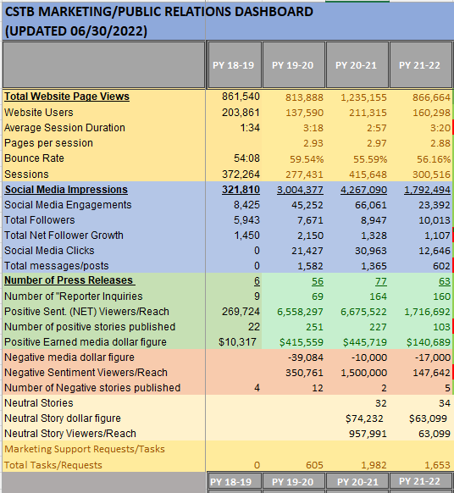

The following are the tools used by CSTB’s Marketing/Public Relations team to deliver direct, clear, and consistent organizational communication to support staff and communicate both to internal and external stakeholders.
Press Release: CSTB Marketing/PR team utilizes the Press Release as the main starting point to execute the CSTB Communication Plan. This allows for a clear understanding of what we are trying to promote in the written language. Often departments will start with a flyer, but a flyer posted online is not picked up or understood by search engines and it does not translate well when trying to get a news organization to cover a story.
- Press Release Vetting Process: The press release also serves as a great way to properly vet the information and make sure the chain of command is aware of what the organization is doing and intends on doing. Marketing/PR Department will work with program to write the press release in a way that can be easily understood by media outlets. This writing style is known as AP style using inverted pyramid.
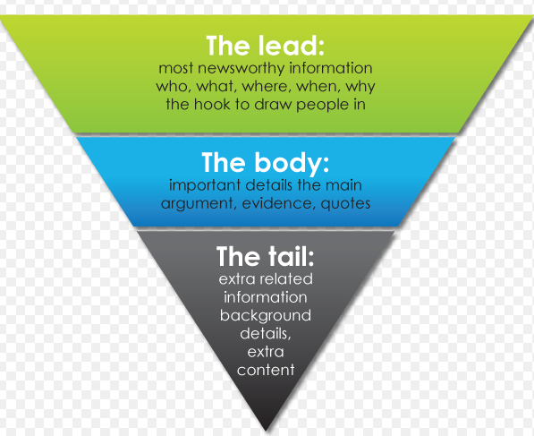

- Once the draft press release is written the marketing team will seek approval from the originator, Program Director, Chief, Leadership Team, Executive Team and finally the CEO. If the press release is part of a joint venture with an outside organization the marketing team will also seek approval from that organization’s communication team as well prior to release of the information.
- Release Date: It is important that the information is not released by the Department until all parties agree to a release date. This ensures that websites are updated, internal audiences are notified, marketing materials are developed, etc. This date is always on the final approved press release. All approved press releases can be found on the CSTB website: https://www.careersourcetampabay.com/news/press-releases/
- We consider our most important audience/PR Channel to be our internal staff and Board Members. They are the ones who will have to implement and promote our programs. Our goal is to make sure CSTB staff is aware of information first.
Support Materials or Marketing Collaterals: Once the press release is finalized the marketing/PR team will work with the department on support materials that will maximize the amount of exposure for whatever we’re trying to promote. This includes possibly using videos, flyers, PowerPoint presentations, social media graphics, website updates, among other things.
Channels: The Marketing/PR team will give the department the approval to release the information. This is the true value in the press release in that every press release can be seen by a wide audience through these channels. Here are the channels the CSTB marketing team uses to disseminate every press release.
CSTB Public Relations Uses these Channels to Increase Exposure of Every Press Release:
CSTB Board of Directors Internal Staff CSTB partners
Hillsborough County Communications News Assignment Desks Reporters
Overall News Media (Media Alert) CSTB Security Chambers
Select Reporters (specific to beat) Tampa Bay Newswire Patch.com
Program Website Community Calendars CSTB Press Release Section
CSTB Social Media Pages @Twitter reporters Hills. Comm College Comms.
Hills. Economic Development Hillsborough Community Orgs. DEO & CS Florida Comms.
CSTB Events Page CSTB Intranet CEO page
Letter to Editor (if needed) Craig’s List (Job Fairs) CEO Twitter

(Please notify marketing if you are aware of a new publication or channel that can help get out our message.)

Marketing can also decide if the press release needs additional exposure and whether to implement the Marketing Plan for each release. At the same time, the Department sends out the release or information from the release to their partners, staff, and other agencies that can help promote information in the release.

Earned Media. Free Publicity generated by Public Relations Team via communicating with media, via social media, partner channels

Owned Media: In 2019 CSTB marketing started producing podcasts to promote CSTB. In 2020, we increased our social media presence to include Spanish social media platforms. We currently are using Facebook, Instagram, Twitter, Linked and YouTube to reach our various audiences. We added TikTok to our youth social media pages in an effort to reach a younger audience.

Measurement: It is important to measure the effectiveness of any public relations effort. The Public Relations team looks at the following measurements:
Press Releases Reporter Inquiries Reach/Viewers Stories Published Earned Media

Brand Ambassador Training: All departments should become familiar with how to work with the Marketing & Public Relations department for events, brochures, communications, press releases and general communication and branding. A training can be requested by reaching out to the VP of Marketing & Public Relations. The PowerPoint for the Brand Ambassador training can be found on the CSTB intranet look for Brand Ambassador Training.

Crisis Management: All issues pertaining to crisis management should bring to the attention of the Equal Opportunity Officer and the VP of Marketing & Public Relations. This includes any issues that potentially could become hot button issues and potentially high-profile media issues. All closings of the offices should also notify the VP of Marketing and Public relations so the CSTB website can be updated, and the media notified when necessary.
CSTB Marketing & Public Relations Policy

CSTB’s Marketing & Public Relations Policy
This policy covers the following areas:
Marketing Request/Procedure Media Inquiries
Corporate Brand Usage Interaction with the News Media
Approved Email Signature CSTB Special Events
Electronic Media Social Media
The policy can be found at this link:
https://careersourcetampabay.com/wp-content/uploads/Policy-Marketing-and-Public-Relations-8.20.20-Rev.-11.21.20.pdf

CSTB Marketing Team

VP Marketing & Public Relations
Doug Tobin
tobind@careersourcetb.com
Extension 2054

Public Relations Manager
Carla Ortiz
ortizc@careersourcetb.com
Extension 7851

Marketing Specialist
Shedlyn Joseph
josephs@careersourcetb.com
Extension 2027

